lab 1 - Proof of Concept (POC)
Generated from the provided screenshots and notes.

Step 1
1


Step 2
attack paraller send
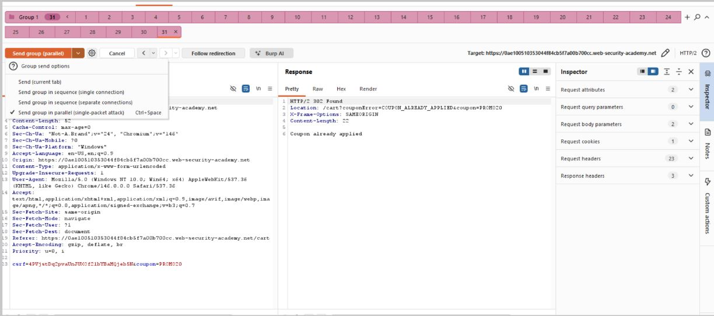

Step 3
capture the request in burp of apply coupurn
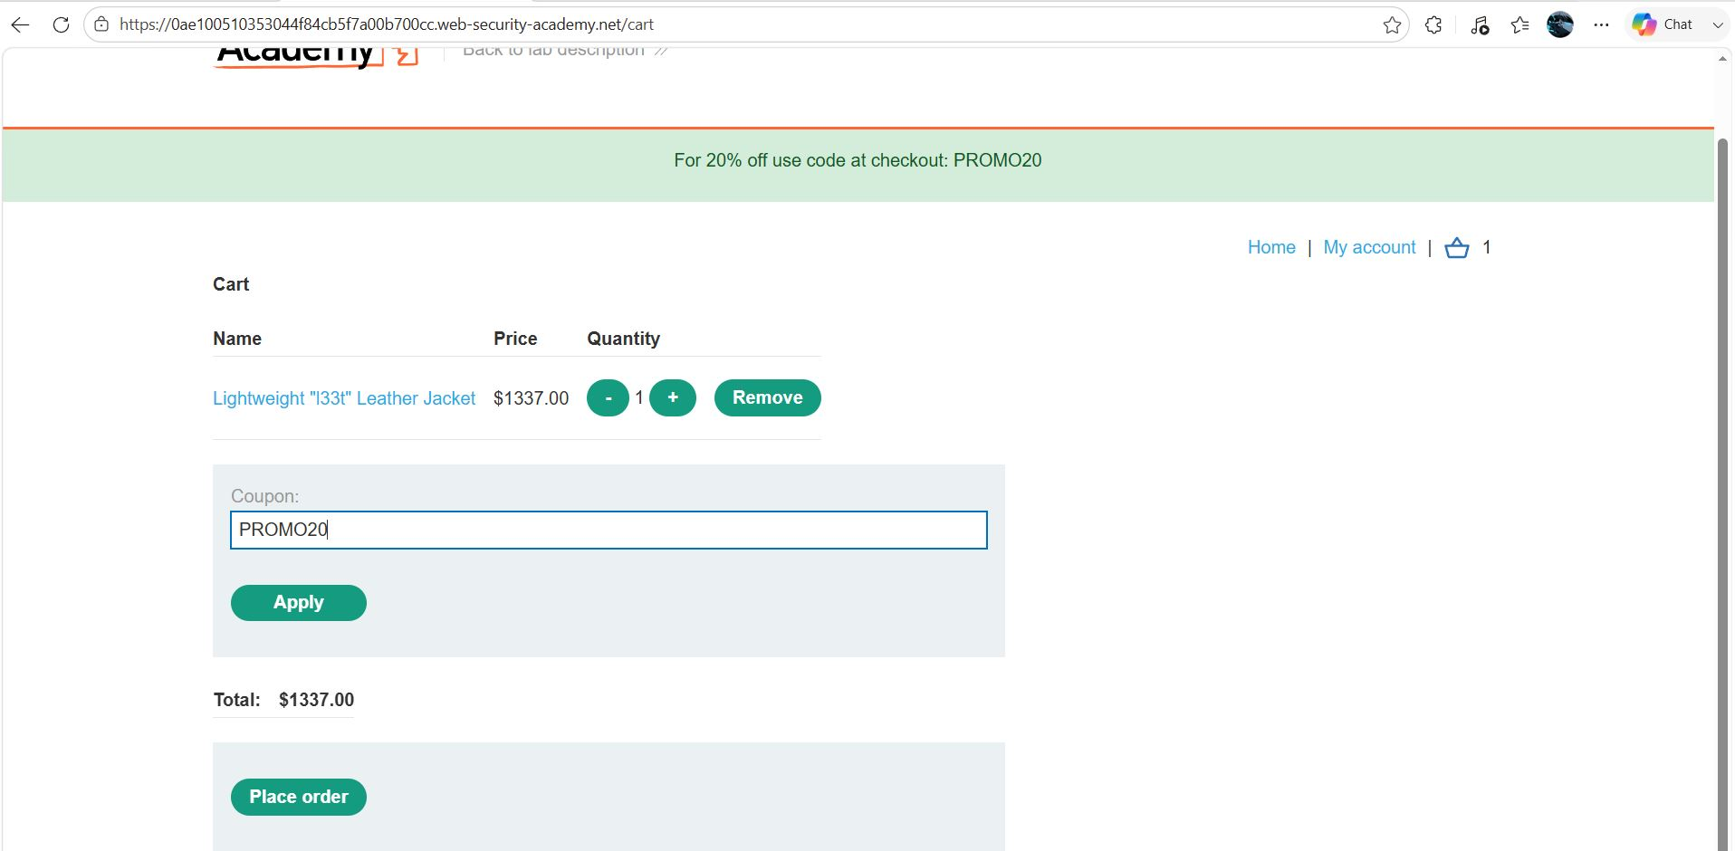

Step 4
price reduce after retry multipe of grp attck request send again and again
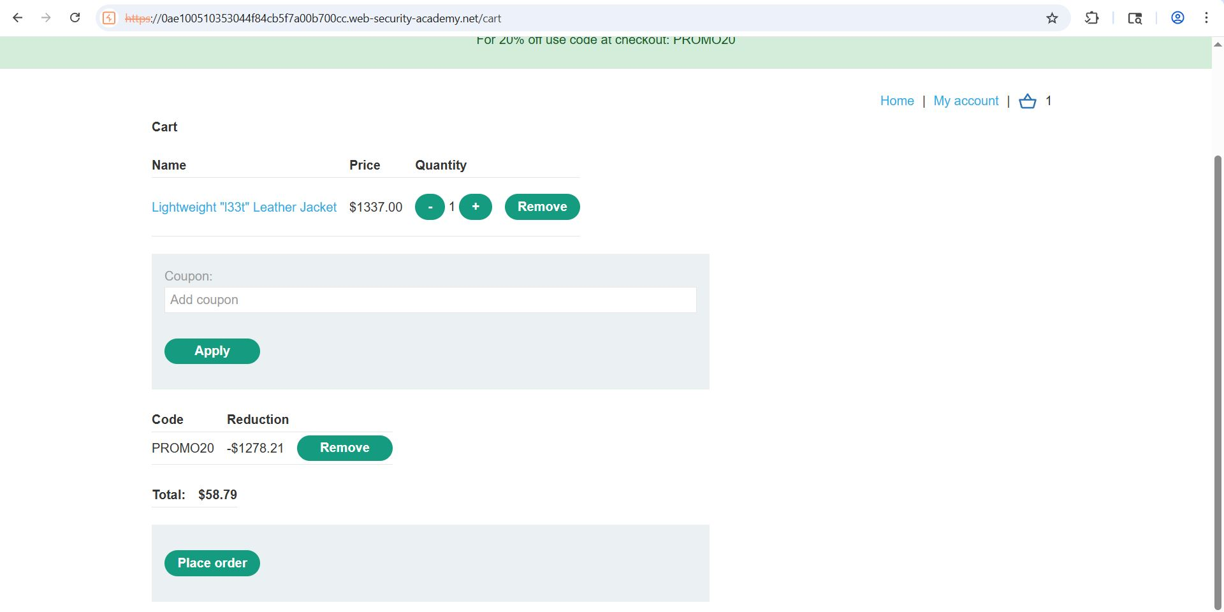

Step 5
request send to reperter
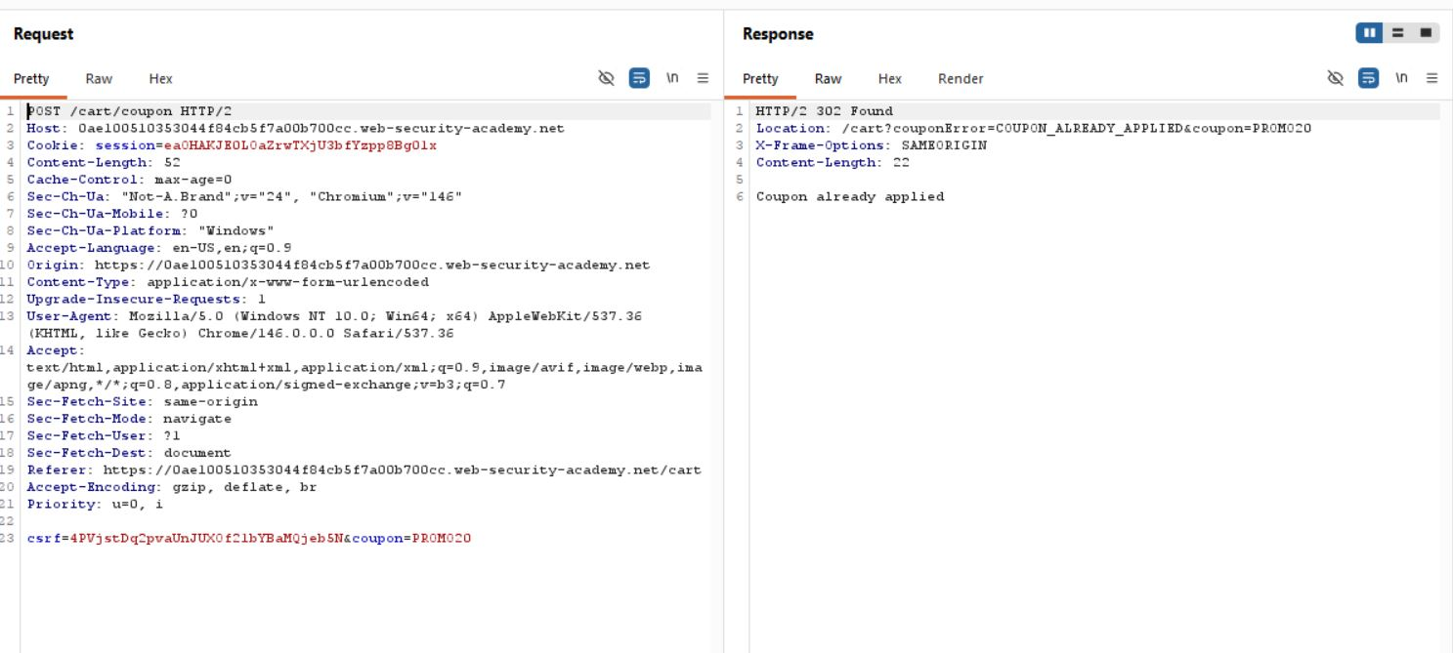

Step 6
send the requesyt multiple time in burp and ceate a grp san set th eparallel attack
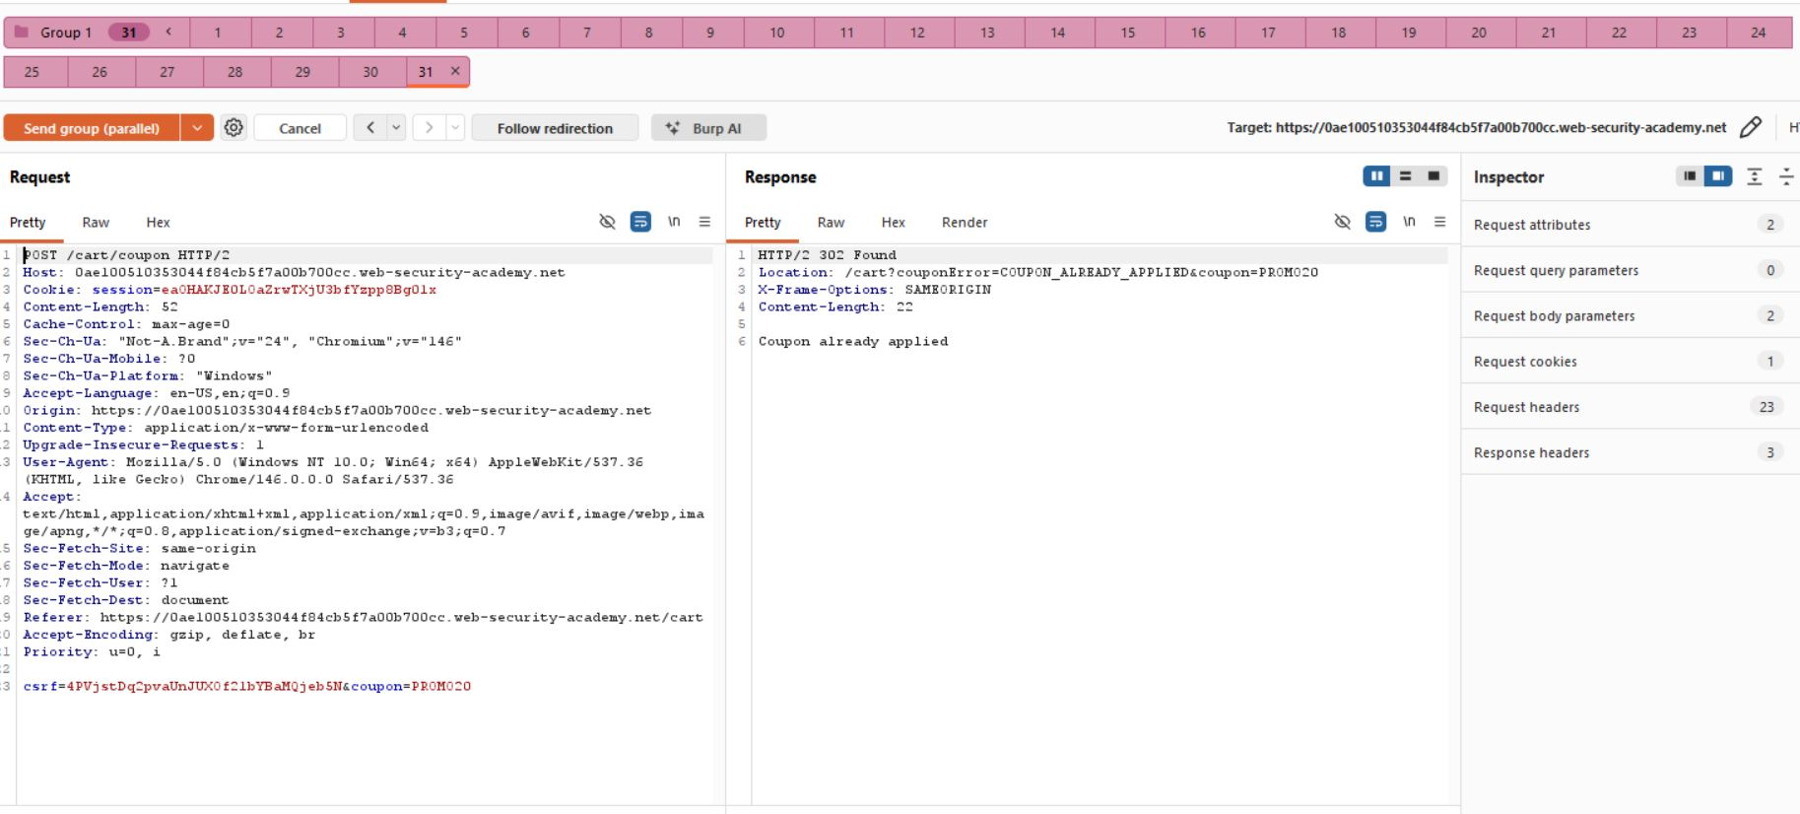

Lab Solved
lab solved
